**Portfolio Optimization Based on Markowitz Model**

Electrical and Electronic Engineering

(general stream)

Shi Yuhan(3035540736)

15/3/2019

This paper selects five stocks (HSBA, BARC, BA, VOD, BATS) to introduce the portfolio optimization process based on Markowitz model within two years (22/1/2016-12/1/2018).

The Markowitz model is about how investors build combinations at a given risk level to maximize expected returns. The basic principle of this theory is that investors build an effective set of portfolios, that is, Effective Frontiers. Effective frontiers maximize expected returns at specific risk levels. Since the correlation and weight of the assets in the portfolio can greatly affect the portfolio benefits, we maximize the expected return by simply constructing the portfolio with different weights.

The formula for defining risks are as follows

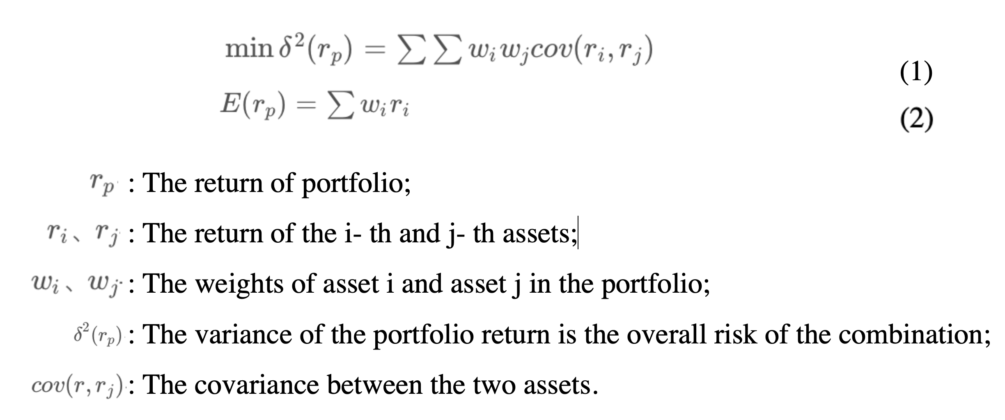

First, we generated a valid frontier combination by Monte Carlo simulation. As shown below. In the figure, the x-axis represents the risk expectation value, and the y-axis represents the expected return value. The lower the risk, the higher the return, the better the portfolio. So the point on the upper left edge of the figure is the best portfolio, which is Markowitz Efficient Frontier.

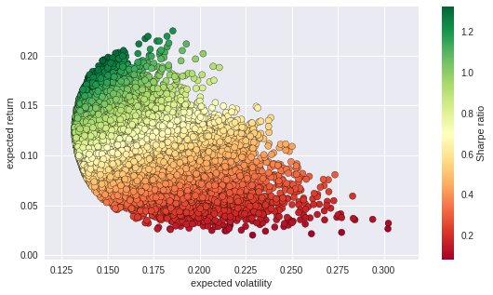

Then we need to determine what the most optimal portfolio is in these combinations.

This paper introduces the Sharpe ratio as the selection criterion for the best optimal portfolio. Sharpe Ratio is the ratio of the additional return (higher than the risk-free rate of return) provided by each portfolio divided by the risk it brings (measured by the standard deviation). The higher the Sharpe Ratio, the higher the return from each unit's risk. For the sake of simplicity, the risk-free rate of return for this paper is set to 2%.

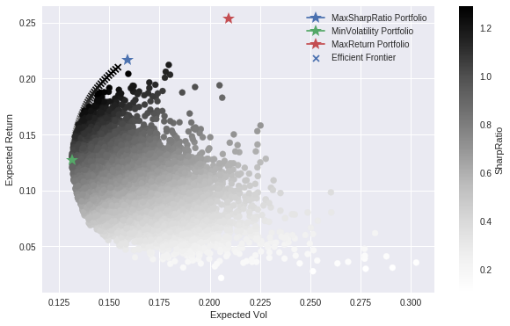

Finally, we will calculate the risk-adjusted rate of return for these combinations (with the Sharpe ratio) and identify the most optimal portfolio in these combinations. 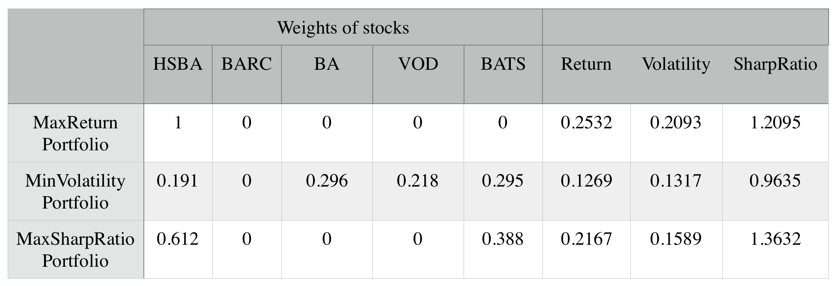

The most risk-averse investor will choose the minimum variance combination, which has a expected rate of return of 12.69% and an expected volatility of 13.17%. The investor with the highest rate of return will choose the largest combination of returns, which may also bring the greatest risk. Its expected rate of return is 25.32% and the expected volatility is 20.93%. Investors seeking the most risk-adjusted yields will build a portfolio with the largest Sharpe ratio, with an expected yield of 21.67% and an expected volatility of 15.89%.